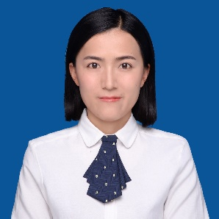
学术报告

题 目：The functional roles of beta carotene oxygenase 2 (BCO2) on energy metabolism
报告人：Lei Wu (吴蕾)， PhD，Research Assistant
Department of Nutritional Sciences, Oklahoma State University
时 间：2018年11月17日 上午10点
地 点：至诚楼G207报告厅
邀请人：冯晴教授

吴蕾博士从事食品活性成分与分子营养相关研究，主要参与的研究项目是类胡萝卜素代谢基因BCO2对线粒体功能的影响及其在肥胖和糖尿病等慢性疾病的致病机理，类胡萝卜素对肥胖和糖尿病等慢性疾病的改善及其肠道微生物的影响，BCO2对小鼠抗流感病毒H1N1感染的免疫机理研究等。

Honors & Awards
2018 2nd place of Emerging Leaders Poster Competition by American Society for Nutrition (ASN)
2018 Outstanding PhD Graduate authorized by Human Sciences at OSU
2018 E. L. and Aagot Jorgenson Memorial Scholarship at OSU
2018 Endowed International Nutritional Sciences Fellowship at OSU
2017 Rapp Foundation Distinguished Graduate Fellowship at OSU
2017 Travel Award for Experimental Biology 2017 authorized by the North American
Chinese Society of Nutrition (NACSN)
2016 Graduate Research Excellence Award at OSU
2016 Graduate Research Award authorized by American Society for Nutrition (ASN)
2015 Travel Award for Experimental Biology 2015 authorized by the NACSN
2014 Top Tier Fellowship at OSU

